第二课时

学习目标：
1 听懂、会说 Happy Birthday to you! How old are you? I'm... 能在实际情境中运用。要求模仿正确，语调自然。
2 能够听说、认读数字1-10 。
学习重点：Happy Birthday! 。How old are you?及相应的回答 。
学习难点：I’m中[m]音的提示；How old are you? 与How are you? 的区分
同步练习
一、选择正确的答案
( ) 1、 How many balloons?

A.4 B. cake C. car

( )2. How many cakes?

A. one cake B. cake C. ball

( )3. How many _______?

A. ducks B. a duck C. duckes
二、 请选择正确的英文翻译。

1.请给我这个。
A . This one ,please. B. This is a plate. C. What’s this?
2.给你。
A. This is a plate. B. How many plates? C. Here you are .
3.有几盘？
A. This one ,please. B How many plates? C. How many pens?

三．根据图片回答问题
1.How many bears？
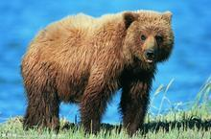_______________________________

2.How many ducks?
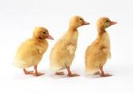____________________________________

3.How many dogs？
_________________________________________.

答案：一、1. A 2. A 3. A
二、1. A 2. C 3. B
三、1. one 2. three 3. two

